Google Analytics

Website: how its working

Performance

How many are opening

Enrolling

Staying

Web analytics

Use:

To tract website activity

Traffic?

Traffic sourse: where these users coming

Device

Gender

Bounce rate: how much time spending on website

Universal Analytics

Google analytics 4 is latest version



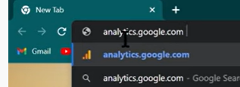

Login

Then acc set up

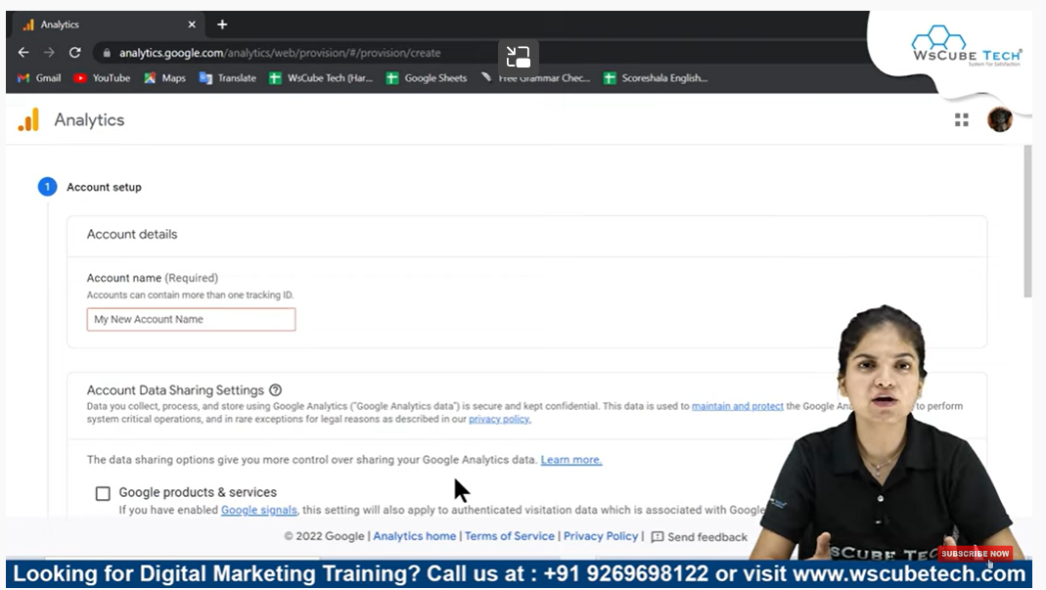

Acc name

Select all

Next

Property set up: which platform or website where u want to tract data

Reporting time

Currency

Advanced option:

Create universal analytics

If u want both

Business info:

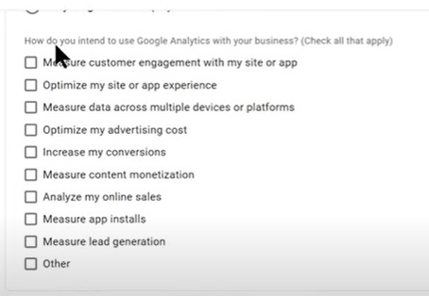

Create

Now terms and condisition

I accept

Now one window comes

Tracking id

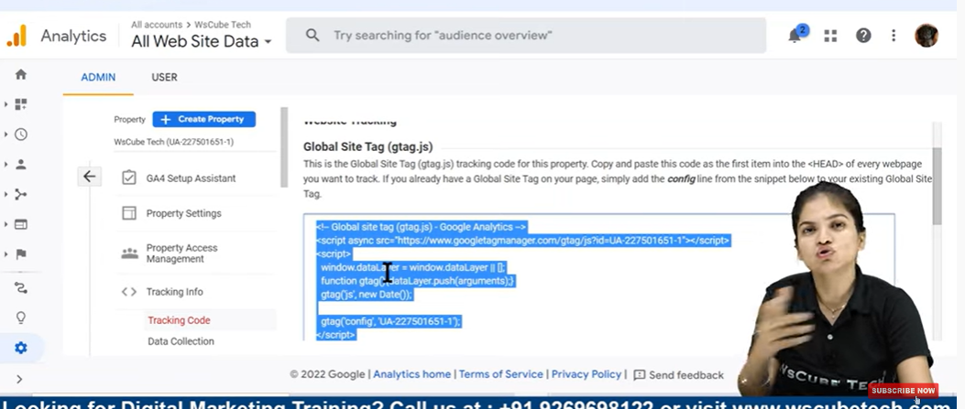

Using this we can get all the information

**How to Setup Google Analytics on WordPress - Complete Installation | Analytics Tutorials**

Copy the tracking code

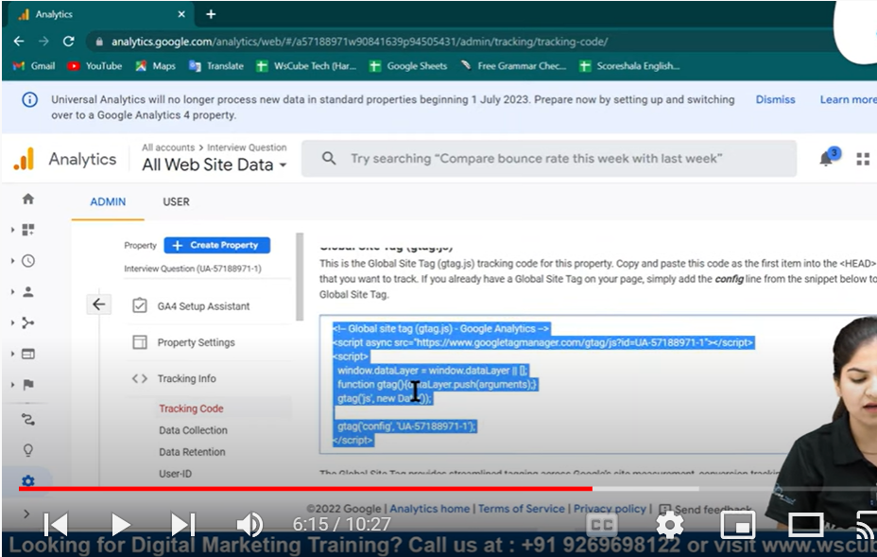

Now word press

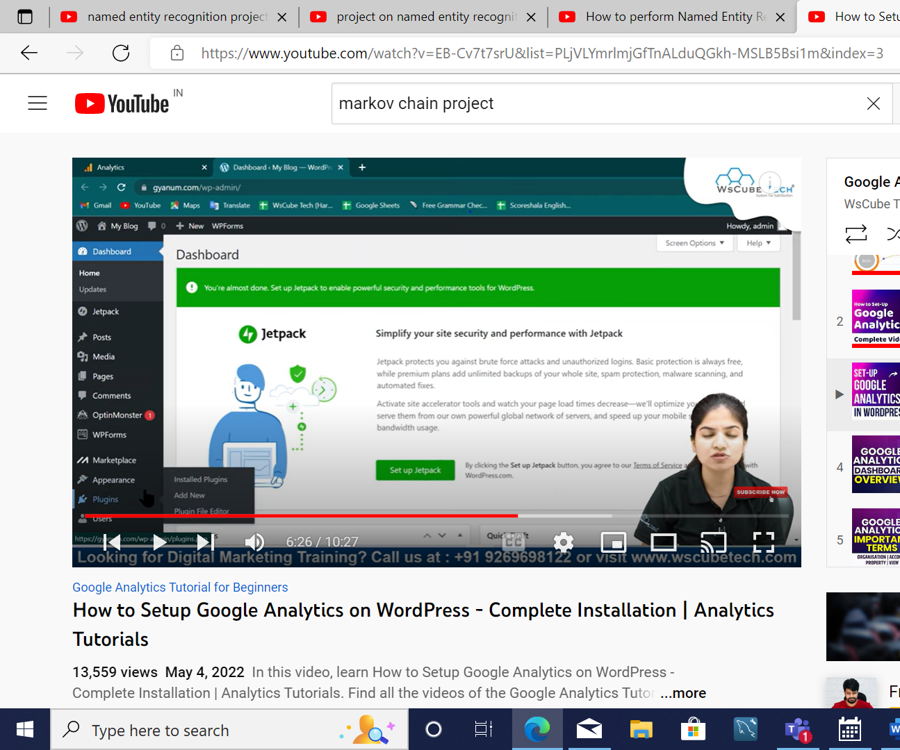

In dash board in appearance

Go to themes file editor

